**SEMESTER 1/1**



**BITS1123**

**COMPUTER ARCHITECTURE**

**AND**

**ORGANIZATION**

**BITC**

**GROUP PROJECT:**

**TEXT -BASED ADVENTURE GAME**

|  |  |
| --- | --- |
| **Name** | **Matric No.** |
| **MUHAMMAD SYAKIR BIN ABD RAZAK** | **B032410068** |
| **HAZRILL IZKHWAN BIN DOLLAH** | **B032410167** |
| **MUHAMMAD HAIKAL BIN MOHD SHAHRIM** | **B032410166** |

**PENSYARAH :**

**DR. ZURINA BINTI SAAYA**

**Introduction to MIPS Assembly Language Programming**

MIPS, or Microprocessor Interlocked Pipeline Stage, is a reduced instruction set computer(RISC) instructon set architecture invented by MIPS Technologies.

Because so many embedded systems use the MIPS processor, learning the MIPS assembly language is tremendously beneficial. It is possible to gain a deeper grasp of how these systems function on a more fundamental level by learning to code in this language.

In MIPS, every instruction is 32 bits long. In the MIPS architecture, a byte correesponds to 8 bits, a halfword to 2bytes, and a word to 4bytes. The MIPS architecture needs 1bytes of storage for each character. There are 4bytes storage requirement for each integer.

**Pseudocode**

START

score = 0

current_puzzle = 0

Display "Welcome to the UTeM Library Escape! Solve math puzzles to escape."

Display "Press Enter to start..."

Wait for user to press Enter

Game_Loop:  
Display "Room: " + rooms[current_puzzle]

Display puzzles[current_puzzle]

Display "Your answer: "

Read user_answer

IF user_answer == correct_answers[current_puzzle]

score += 20

Display "Correct! Your score is now: " + score

ELSE

score -= 20 (minimum is 0)

Display "Incorrect! The correct answer was " + correct_answers[current_puzzle]

Display "Your score is now: " + score

IF score == 0

Display "You didn't manage to escape this time. Keep trying."

End IF

IF score >= 100

Display "Congratulations! You've escaped with a score of " + score

End IF

Display "\nPress 1 for next puzzle, 2 for previous puzzle, or any other key to quit: "

Read user_answer

IF user_answer == "1"

current_puzzle += 1 (max is 4)

ELSE IF user_answer == "2"

current_puzzle -=1 (min is 0)

ELSE

Display "You didn't manage to escape this time. Keep trying."

End IF

STOP

**Source Code**

.data

puzzles:

.asciiz "What is 5 + 3?\n"

.asciiz "What is 10 - 7?\n"

.asciiz "What is 4 * 6?\n"

.asciiz "What is 15 / 3?\n"

.asciiz "Is 7 an even or an odd number?\n"

correct_answers:

.asciiz "8\n"

.asciiz "3\n"

.asciiz "24\n"

.asciiz "5\n"

.asciiz "odd\n"

rooms:

.asciiz "Free Area\n"

.asciiz "Computer Room\n"

.asciiz "Meeting Room\n"

.asciiz "Chill Area\n"

.asciiz "Private Room\n"

welcome_msg: .asciiz "Welcome to the UTeM Library Escape! Solve math puzzles to escape.\n"

correct_msg: .asciiz "Correct! Your score is now: "

incorrect_msg: .asciiz "\nIncorrect! The correct answer was "

score_now: .asciiz "Your score is now: "

escape_msg: .asciiz "\nCongratulations! You've escaped with a score of "

navigation_msg: .asciiz "\nPress 1 to go to the next puzzle, or 2 to go back to the previous puzzle (or any other key to quit):\n "

failed_msg: .asciiz "You didn't manage to escape this time. Keep trying\n"

newline: .asciiz "\n"

score: .word 0

current_puzzle: .word 0

user_answer: .space 20

one_str: .asciiz "1\n"

two_str: .asciiz "2\n"

.text

main:

**# Display welcome message**

li $v0, 4

la $a0, welcome_msg

syscall

**# Display start message**

li $v0, 4

la $a0, start

syscall

**# Get user input to start game**

li $v0, 8

la $a0, user_answer

li $a1, 20

syscall

**# Add newline for separation**

li $v0, 4

la $a0, newline

syscall

**# Initialize score and puzzle index**

li $t0, 0

sw $t0, score

sw $t0, current_puzzle

game_loop:

**# Display current rooms**

lw $t0, current_puzzle

la $t1, rooms

jal get_string_offset

move $a0, $t1

li $v0, 4

syscall

**# Display current puzzle**

lw $t0, current_puzzle

la $t1, puzzles

jal get_string_offset

move $a0, $t1

li $v0, 4

syscall

**# Get user input**

li $v0, 8

la $a0, user_answer

li $a1, 20

syscall

**# Compare answer**

lw $t0, current_puzzle

la $t1, correct_answers

jal get_string_offset

move $a1, $t1

la $a0, user_answer

jal compare_strings

bnez $v0, incorrect

correct:

**# Increase score**

lw $t0, score

addi $t0, $t0, 20

sw $t0, score

**# Display correct message and score**

li $v0, 4

la $a0, correct_msg

syscall

li $v0, 1

lw $a0, score

syscall

**# Add newline for separation**

li $v0, 4

la $a0, newline

syscall

j navigation

incorrect:

**# Decrease score, but not below 0**

lw $t0, score

subi $t0, $t0, 20

bgtz $t0, valid_score

li $t0, 0

valid_score:

sw $t0, score

**# Check if score reached zero to terminate**

beqz $t0, end_game

**# Display incorrect message and correct answer**

li $v0, 4

la $a0, incorrect_msg

syscall

lw $t0, current_puzzle

la $t1, correct_answers

jal get_string_offset

move $a0, $t1

li $v0, 4

syscall

li $v0, 4

la $a0, score_now

syscall

li $v0, 1

lw $a0, score

syscall

**# Add newline for separation**

li $v0, 4

la $a0, newline

syscall

navigation**:**

**# Check if score is high enough to escape**

lw $t0, score

li $t1, 100

bge $t0, $t1, escape

**# Display navigation options**

li $v0, 4

la $a0, navigation_msg

syscall

**# Read user choice as string**

li $v0, 8

la $a0, user_answer

li $a1, 20

syscall

**# Check input**

la $a0, user_answer

la $a1, one_str

jal compare_strings

beqz $v0, next_puzzle

la $a0, user_answer

la $a1, two_str

jal compare_strings

beqz $v0, prev_puzzle

j end_game

next_puzzle:

lw $t0, current_puzzle

addi $t0, $t0, 1

li $t1, 4

ble $t0, $t1, update_puzzle_index

li $t0, 4

update_puzzle_index:

sw $t0, current_puzzle

j game_loop

prev_puzzle:

lw $t0, current_puzzle

addi $t0, $t0, -1

bgez $t0, update_puzzle_index

li $t0, 0

j update_puzzle_index

escape:

**# Display escape message**

li $v0, 4

la $a0, escape_msg

syscall

li $v0, 1

lw $a0, score

syscall

exit:

li $v0, 10

syscall

end_game:

li $v0, 4

la $a0, failed_msg

syscall

j exit

get_string_offset:

move $t2, $zero

loop_offset:

beq $t0, $zero, return_offset

subi $t0, $t0, 1

find_next_string:

lb $t3, 0($t1)

beqz $t3, update_offset

addi $t1, $t1, 1

j find_next_string

update_offset:

addi $t1, $t1, 1

j loop_offset

return_offset:

jr $ra

**# Simplified string comparison function**

compare_strings:

move $t0, $a0

move $t1, $a1

compare_loop:

lb $t2, 0($t0)

lb $t3, 0($t1)

beqz $t2, check_end

bne $t2, $t3, not_equal

addi $t0, $t0, 1

addi $t1, $t1, 1

j compare_loop

check_end:

beqz $t3, equal

not_equal:

li $v0, 1

j return_compare

equal:

li $v0, 0

return_compare:

jr $ra

**Output Sample**

Program start with Welcome message and You must press Enter to start the game.

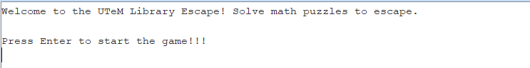

After you press Enter it will appear which rooms you are in and puzzle that you need to solve. Every correct answer you will get 20 points.

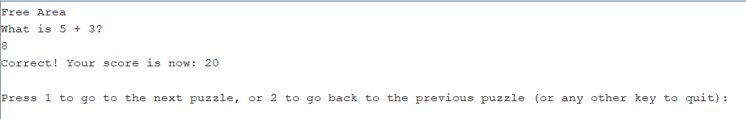

For every incorrect answer it will show the correct answer for the puzzle and your score will be deduct by 20 points.

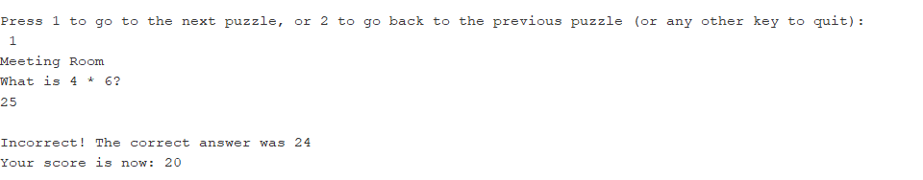

If you choose 1 then you will be move to the next puzzle.

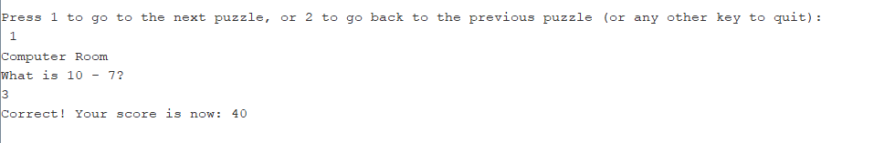

If you choose 2 then you will be move to the previous puzzle.

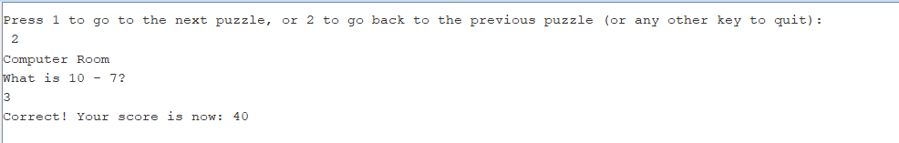

Once you get 100% score there will be escape message appears.

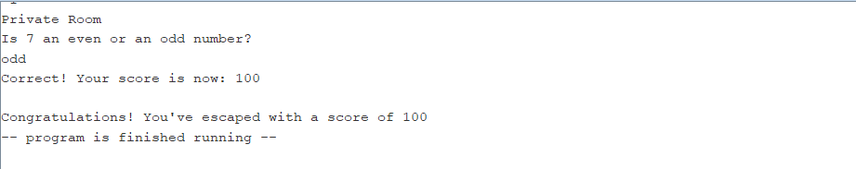

Otherwise , If you got 0% score the program will display failed message.

